New Teacher Orientation- Educational Technology

Big Ideas | Details | Your Notes
Chrome   | Best browser for working with Google Products.  - Sign into Chrome (3 dots in upper right corner)  - Go to http://curlew.wednet.edu/  - Favorite the site | When in doubt use firefox, safari, etc.
Google Classroom   | Classroom Workflow  - Easily share and manage online work with students and automate permissions.  Try it:  - Go to classroom.google.com  - Choose “I am a teacher”  - Click the + to join our class  - Code:______
Equipment   | Classroom Devices:  Staff Laptops (Mic & camera built in)  Docking station with keyboard & mouse  Document Camera  Sound Amplification System  Projector  Student Devices:  Kinder teachers: iPads  Grades 3-12: 1:1 Laptops  K-2: Shared iPad & Laptop Carts
Logins     | Computer login  - Username: firstinitial fulllastname or firstname lastname  Example: cdavidson/cody davidson  - Password:  Google  Staff username firstinital.fulllast@curlew.wednet.edu  Student username  first.last@curlew.wednet.edu  Password: different than computer login  Password Reset  - IT Techs can reset student/staff passwords. | Most if not everyone's username is first initial full lastname. Some its first name lastname. (its standard firstinitial fulllastname) unless there's a student with the same initials then it will be different. Same as staff members.  As above, the same goes for email login.
Wifi   | All wifi is filtered the same as a kindergarten account  - chs-wlan: No PW needed
Skyward  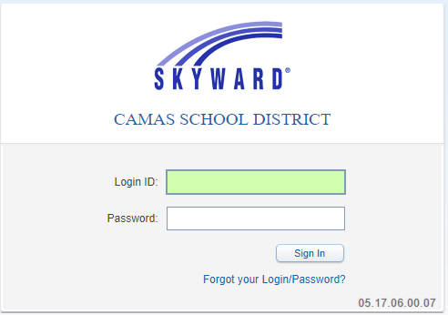 | Student Information System  https://www2.nerdc.wa-k12.net/scripts/cgiip.exe/WService=wcurlews71/fwemnu01.w  User name: firstinitallastname  Example: cdavidson  Default Password: cougar  Employee Access  - Pay Stubs  - Clock Hours  Teacher Access  - Attendance  - Email  - Letter to Parents  Administrator Access  - Student Search by Entity
Help Desk    https://curlewschool.on.spiceworks.com/portal/registrations | CHS Help Desk  - Device Needs / escalated as needed  - Software Requests / escalated as needed  - Report Computer issues
Google Drive   | Everywhere & Anytime Files  drive.google.com  - Organization  - File Types  - Sharing  - Collaboration & Comments
Google Classroom | Classroom Workflow  - Self grading quiz  - Question  - Stream

At Your Own Pace
School Phones  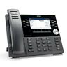 | These phones use VoIP technology. Phones should NOT be moved from port to port, as they are tied in with the 911 emergency system.  - Default password: 11111  - Ask IT to reset password for Voicemail  - Will be asked to set it again and the pin needs to be 4 or 5 characters long.  - NuPoint Mitel TUI QRG_8.2 - Copy.fm.pdf
Email on Mobile Phone   | Email on mobile phone  - https://support.apple.com/en-us/HT201320  - https://support.google.com/mail/answer/8494?hl=en&ref_topic=7065107&co=GENIE.Platform%3DAndroid&oco=1

